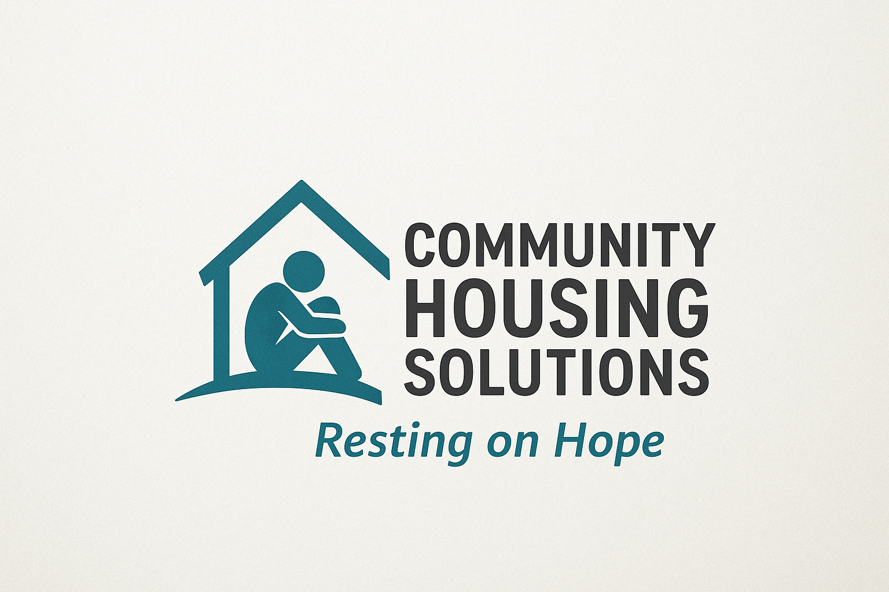
INTAKE FORM
Home: |  | Room#
Move-In Date |  | Rent Amt. | $
End of Probation |  | Fee/Deposit | $

Resident - General Information

First Name: ________________________________ Middle Name: ____________________ Last Name: __________________________________ NickName:_____________________ Preferred Pronoun: ____________________ Gender at birth: ________________________ Phone #: (_____)_________-___________ Email: ________________________________
Secured Information

Date Of Birth: _____/________/_________ SSN/ITIN #: _______ -________-__________ ID/CDL#: ___________________________ Military ID #: ___________________________ Marital Status: ________________ Spouse's Name: ___________________ Phone ______________

Financial Information

Monthly Income 1: $___________________ Source 1: ___________________________ Monthly Income 2: $___________________ Source 2:____________________________ Other Monthly Income: $ _______________ Available Savings: $___________________ Expenses: Cell Phone Car Loans Other
What is the total of your monthly expenses? $____________________
Intake Form Rev. 1 Copyright 2023 1
Emergency Information

Emergency Contact Information
First Name: ___________________________ Last Name:____________________________ Phone #: (_____)_________-___________ Email: ________________________________ Relationship To You: __________________________
First Name: ___________________________ Last Name:____________________________ Phone #: (_____)_________-___________ Email: ________________________________ Relationship To You:: __________________________

Medical Information
Do you have Medical Insurance?
Provider: _____________________ Health Card #: ______________________ Contact #: (____) ____________________
Do you have any allergies or dietary restrictions? Provide details below.
List Medications:
__________________________________________________________________________ __________________________________________________________________________ __________________________________________________________________________
List Food/ Beverages:
__________________________________________________________________________ __________________________________________________________________________ __________________________________________________________________________
Other:
__________________________________________________________________________ __________________________________________________________________________ __________________________________________________________________________
Do you have any chronic medical issues we should be concerned about? (Example: Diabetes, COPD, etc.) Please provide details below:
__________________________________________________________________________ __________________________________________________________________________ __________________________________________________________________________ __________________________________________________________________________
Do you have any special medical equipment?
__________________________________________________________________________ __________________________________________________________________________ __________________________________________________________________________
Have you been exposed to someone with COVID-19?(Circle) Yes No
IF YES, please explain:
__________________________________________________________________________ __________________________________________________________________________ Are you currently experiencing any of the symptoms listed below? (Circle)
Fever Dry Cough Flu-like Symptoms
Resident Suitability Questionnaire ***

Can you walk independently?(Circle) Yes No Sometimes
If No or Sometimes Explain:_________________________________________________ ________________________________________________________________________
Can you participate in household cleaning and chores?(Circle) Yes No
If No or Sometimes Explain:_________________________________________________ ________________________________________________________________________
Can you bathe and dress yourself? (Circle) Yes No
If No or Sometimes Explain:__________________________________________________ ________________________________________________________________________ Do you bathe every day? (Circle) Yes No
If No or Sometimes Explain:__________________________________________________ ________________________________________________________________________
Do you have any issues with bladder control?(Circle) Yes No Sometimes If No or Sometimes Explain:__________________________________________________ _________________________________________________________________________ Are you on Probation or Parole? Yes No
If Yes, provide information:
Probation/Parole Officer Name: ___________________________ End Date: ___/____/____ Probation/Parole Contact #: (_____)_________-___________ CDC #: _________________

Resident Suitability Questionnaire Continued

Do you smoke? (Circle) Yes No
IF YES, please explain:
__________________________________________________________________________ __________________________________________________________________________ Are you recovering from any addiction that we should be aware of?(Circle) Yes No IF YES, please explain:
__________________________________________________________________________ __________________________________________________________________________ What time do you normally go to bed? __________________ PM
Do you have any regular medical appointments? Please explain.
__________________________________________________________________________ __________________________________________________________________________ List food items that you do not like:
Meats: ________________________________________________________ Vegetables: ____________________________________________________ Other: ________________________________________________________
List your favorite foods:
Meats: ________________________________________________________ Vegetables: ____________________________________________________ ther: _________________________________________________________
Intake Form Rev. 1 Copyright 2023 5
Resident Suitability Questionnaire Continued

List Activities you enjoy doing:
__________________________________________________________________________ __________________________________________________________________________ List concerns you may have living with a roommate?
__________________________________________________________________________ __________________________________________________________________________ Do you work or volunteer anywhere?
__________________________________________________________________________ __________________________________________________________________________ List ANYTHING else we should be concerned about.
__________________________________________________________________________ __________________________________________________________________________ __________________________________________________________________________ __________________________________________________________________________ __________________________________________________________________________ __________________________________________________________________________ __________________________________________________________________________
The information I have provided above is true and accurate to the best of my knowledge. I understand that if I have not provided true and accurate information that it will be grounds for eviction.
Signature: ______________________________________ Date: __________________

OFFICE USE ONLY: Circle Yes if applicable
Temperature Check (enter temperature taken) | _________ F
Copy of ID/CDL | Yes
Copy of Proof of Military Service** | Yes
Proof of Income - Confirmation | Yes
Move-In Fee Received | Yes
Deposit Received | Yes
Initial Rent (Prorated) Received | Yes
COVID-19 Disclaimer Signed | Yes
License Agreement Signed | Yes
Pool Waiver Signed | Yes

